EXP. NO: 1
Estimation of Characteristic Impedance (Zo), and Propagation Constant(γ) of a Transmission Line from Primary Constants.

Test Case 1:
Investigating the significance of Characteristic Impedance (Zo), and Propagation Constant
(γ) of a Transmission Line using the following parameters
a) Resistance =10 Ω/Km
b) Capacitance = 8 μF/Km
c) Inductance =3.5 mH/Km
d) Conductance =4 μmho/Km
e) Frequency= 2 Khz

AIM: Investigating the significance of Characteristic Impedance (Zo), and Propagation
Constant (γ) of a Transmission Line with Resistance =10 Ω/Km, Capacitance = 8 μF/Km, Inductance
=3.5 mH/Km, Conductance =4 μmho/Km, Frequency= 2 Khz
SOFTWARE REQUIRED:
SCILAB Version 6.1.1
PROCEDURE:
● Open SCILAB software
● Open file-new
● Put the input values
● Type the program
● Execute the program
● End the program
PROGRAM:
clear; clc;
R=10;L=0.003;f=2*10^3;G=4*(10^-6);C=16*(10^-6);
w=2*%pi*f;
Z=R+(%i*w*L);
Y=G+(%i*w*C);
Zo=sqrt(Z/Y);
C=round(real(Zo));
D=round(imag(Zo));
printf('-Zo = %f + j(%f)ohms\n',C,D);
P=sqrt(Z*Y);
a=real(P);
a1=round(a*10000)/10000;
printf('-Attenuation constant a = %f neper/km\n',a1);
b=imag(P);
b1=round(b*10000)/10000;
printf('-Phase constant b = %f radians/km',b1);
OUTPUT:
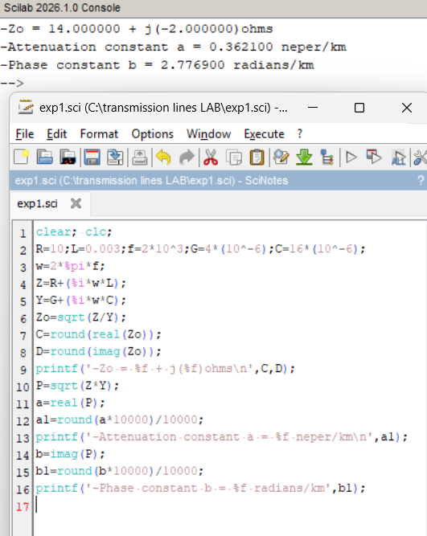

RESULT:
The characteristic impedance and propagation constant of a transmission line is calculated using
SCILAB and the impact of primary constants on secondary constants are investigated.

